English
Name: final exam 1st grade:

Question number one: write the numbers:

Question number two: read and complete
A a |  | C c | D d |  |  | G g |  | I i
 | K k |  | M m | N n |  |  | Q q
S s |  | U u |  | W w |  | Y y

Question number three: write the missing letters:
h | a | f | s | o


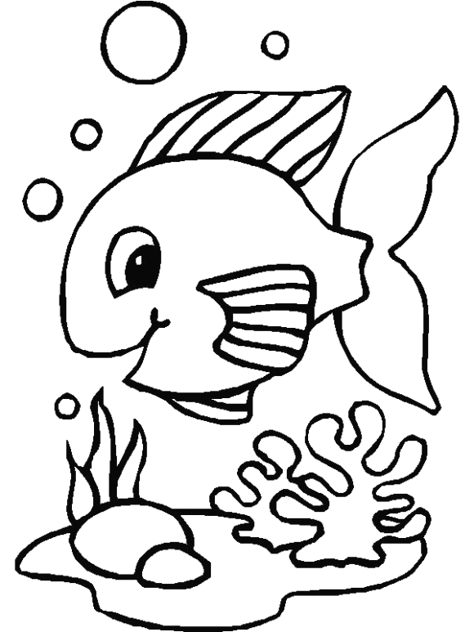
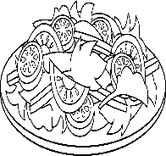
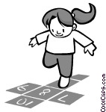

pple op alad ish range

Question number four:
Hand | Head | Arm | leg | Feet
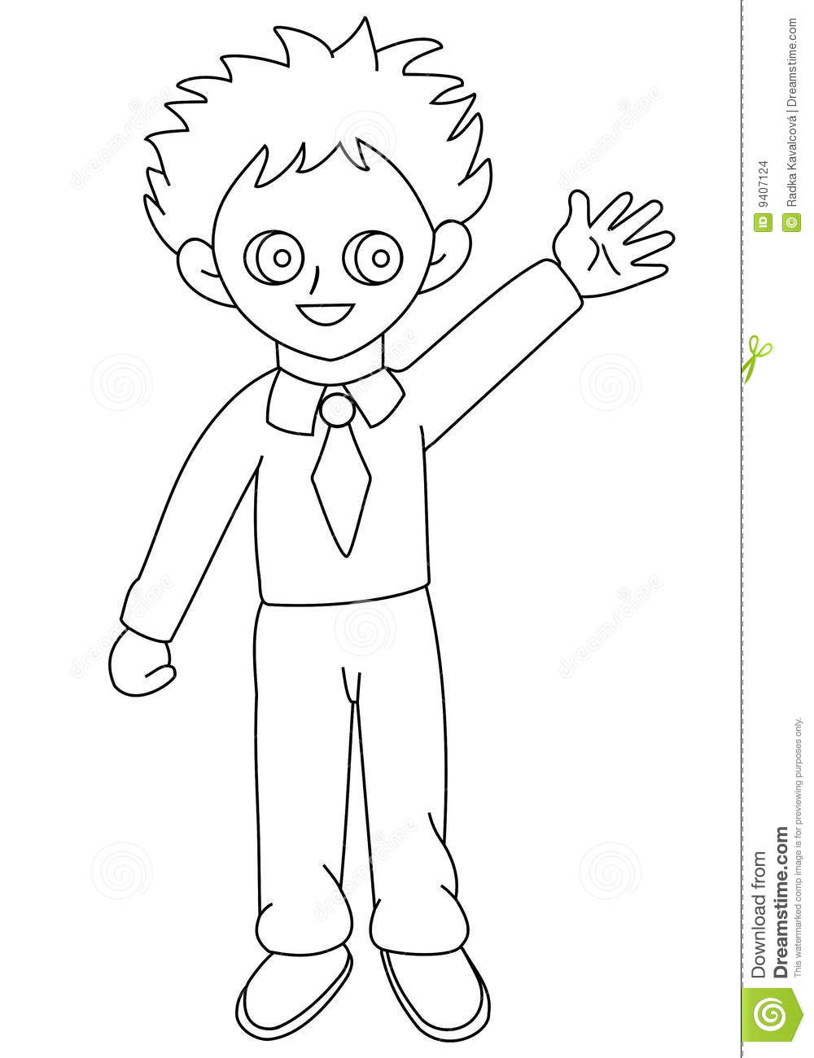
4
1

2

3
5

